**Ideation Phase**

**Empathize & Discover**

|  |  |
| --- | --- |
| Date | 31 January 2025 |
| Team ID | LTVIP2025TMID43995 |
| Project Name | Transfer Learning-based Classification of Poultry Diseases for Enhanced Health Management |
| Maximum Marks | 4 Marks |

**Empathy Map Canvas:**

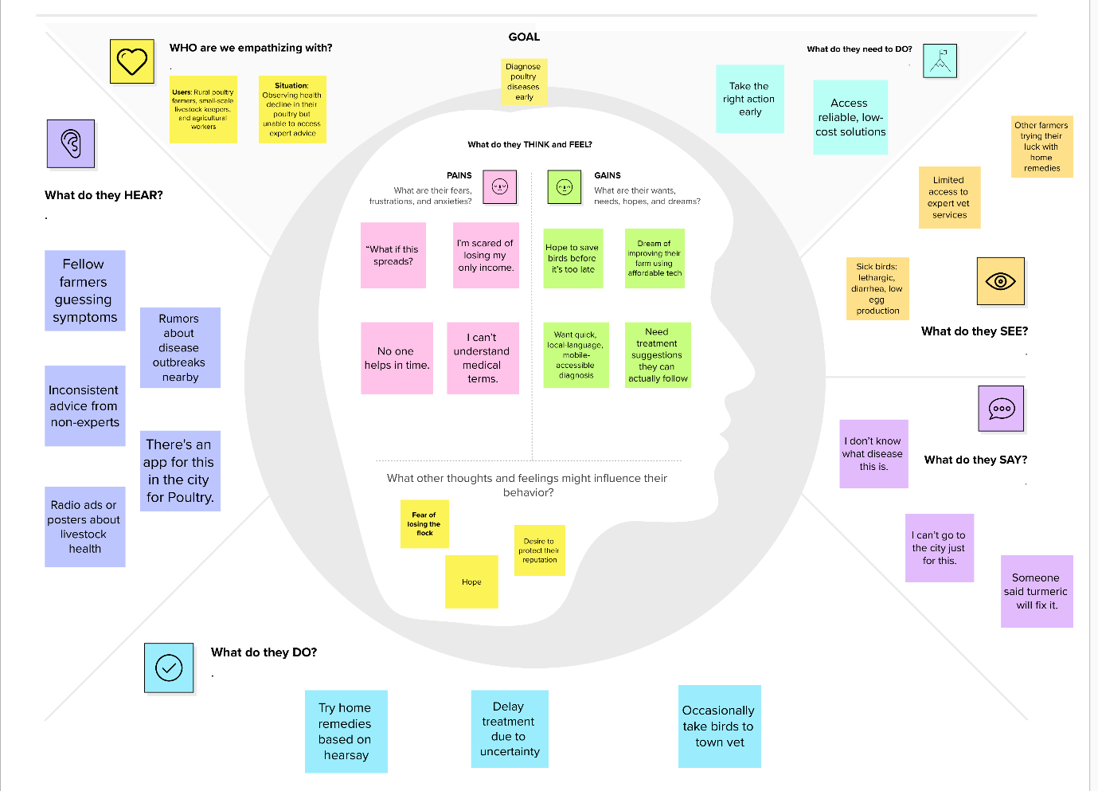

Reference: [Empathy map canvas • SmartBridge_STB3_LTVIP2025TMID43995](https://app.mural.co/t/smartbridgestb3ltvip2025tmid1993/m/smartbridgestb3ltvip2025tmid1993/1751025878095/a476c8073d13be0f5eed31be8afb1053bfee0f0b)